SCUBA-2 Block Specification
fsfb_calc

Revision History
Rev. 1.1 AK, Initial Release
Rev. 2.0 MA, A 2-pole Butterworth low-pass filter is added
Rev. 2.1 MA, updated Lock-mode timing diagram
Rev. 2.2 MA, added document number

September 15, 2006
Table of Contents

1. Block Overview 4
1.1 Block Location and Block Interface Within System 4
1.2 Block Functionality / Features 4
1.3 Block Dataflow 5
2. Block Interfaces 7
2.1 Interface Signal Description 7
2.2 Interface Protocol and Timing 9
2.2.1 Constant Mode Timing 9
2.2.2 Ramp Mode Timing 10
2.2.3 Lock Mode Timing 12
3. High-Level Description 13
3.1 RAM Storage Blocks 13
3.1.1 First Stage Feedback Queue (fsfb_queue) Bank 0 (Even) and 1 (Odd) 13
3.1.2 Flux Count Queue – Bank 0 and Bank 1 14
3.1.3 First Stage Feedback Filter Queue 14
3.1.4 First-Stage Feedback Filter Registers 14
3.2 First Stage Feedback Processor (fsfb_processor) 15
3.2.1 Constant Mode 17
3.2.2 Ramp Mode (fsfb_proc_ramp) 17
3.2.3 Lock/PIDZ Mode (fsfb_proc_pidz) 18
3.3 First Stage Feedback Input/Output Controller (fsfb_io_controller) 19
4. Files of the Block 21
4.1 Source Code 21
4.1.1 Fsfb_calc.vhd 21
4.1.1.1 Fsfb_processor.vhd 21
4.1.1.2 Fsfb_io_controller.vhd 21
4.1.1.3 Fsfb_queue.vhd 22
4.1.1.4 fsfb_filter_storage 22
4.1.1.5 fsfb_fltr_regs 22
4.1.1.6 flux_cnt_queue.vhd 22
4.2 Header Code 22
4.2.1 Fsfb_calc_pack.vhd 22
5. Naming Conventions Used 23

Table of Figures

Figure 1: fsfb_calc block in the system 4
Figure 2: First Stage Feedback Calculator (fsfb_calc) 6
Figure 3: Interface Timing Diagram 1 (Constant Servo Mode) 9
Figure 4: Interface Timing Diagram 2-1 (Ramp Servo Mode) 10
Figure 5: Interface Timing Diagram 2-2 (Ramp Servo Mode) 11
Figure 6: Interface Timing Diagram 3 (Lock Servo Mode) 12
Figure 7: First Stage Feedback Queue Data Word 13
Figure 8: First Stage Feedback Queue 14
Figure 9: First Stage Feedback Filter Queue 14
Figure 10: Filter Registers Storage 15
Figure 11: First Stage Feedback Processor 16
Figure 12: First Stage Feedback Ramp Processor 17
Figure 13: First Stage Feedback Lock/PIDZ Processor 19
Figure 14: First Stage Feedback Input/Output Controller 20

Block Overview

Block Location and Block Interface Within System
The first stage feedback calculator (fsfb_calc) block is instantiated inside each flux loop control block (flux_loop_ctrl) found on the readout card. On each card, there are eight flux_loop_ctrl blocks responsible for the eight different channels. All the eight flux loop control blocks are identical in functionality and features. This common architecture provides convenience on any future code verification, upgrade and support since it makes no difference to test which of the eight channels. However, this architecture is quite resource intensive due to its parallel nature.
The first stage feedback calculator (fsfb_calc) stands in the middle of the system datapath. Its upstream input side is interfaced with the adc_sample_coadd block while its downstream output side is interfaced with the flux jumping (fsfb_corr) and wishbone (wbs_fb_data and wbs_fb_frame) blocks.
wbs_fb_data
flux_loop_ctrl
fsfb_ctrl
fsfb_calc
adc_sample_coadd
fsfb_corr
DAC
wbs_frame_data

Figure 1: fsfb_calc block in the system

Block Functionality / Features
The fsfb_calc block is responsible for calculating the first stage feedback values, storing them in the first stage feedback queues (fsfb_queue), low-pass filtering the feedback values and storing the filtered results, providing feedback wishbone (wbs_frame_data) and correction block (fsfb_corr) access to the queue storage elements. It has the following main features:
- Supports three different servo mode calculations: constant/ramp/lock (also called dynamic).
- Selects the outputs based on the servo mode selection setting with disable feature.
- Filters the feedback data through a 2-pole Butterworth low-pass filter with centre frequency set at 50Hz. Filter coefficients are currently hard coded in fsfb_calc_pack.vhd file.
- Provides following storage RAM:
  - 2 64 x 40bit RAM blocks (banks) of first stage feedback queue storage (odd and even, where the MSb is used only in ramp mode to indicate the slope of the ramp) for simultaneous accesses of previous and current frame results without arbitration.
  - 2 64 x 8bit RAM blocks (banks) for flux-jump-count storage.
  - A 64 x 32bit RAM block for storing filter results.
  - A 64 x 29bit RAM block for storing intermediate filter calculation terms or so-called wn terms.
- Generates smooth output transition following the assertion of initialize window input after test parameter settings change.
- Outputs ready signals together with valid data results to all downstream blocks for handshaking ease.

Block Dataflow
Figure 2 shows the block dataflow for the first stage feedback calculator (fsfb_calc) block. The first stage feedback processor (fsfb_processor) handles the entire data processing task while the first stage feedback input/output controller (fsfb_io_controller) takes care of all the I/O access timings with the queues.
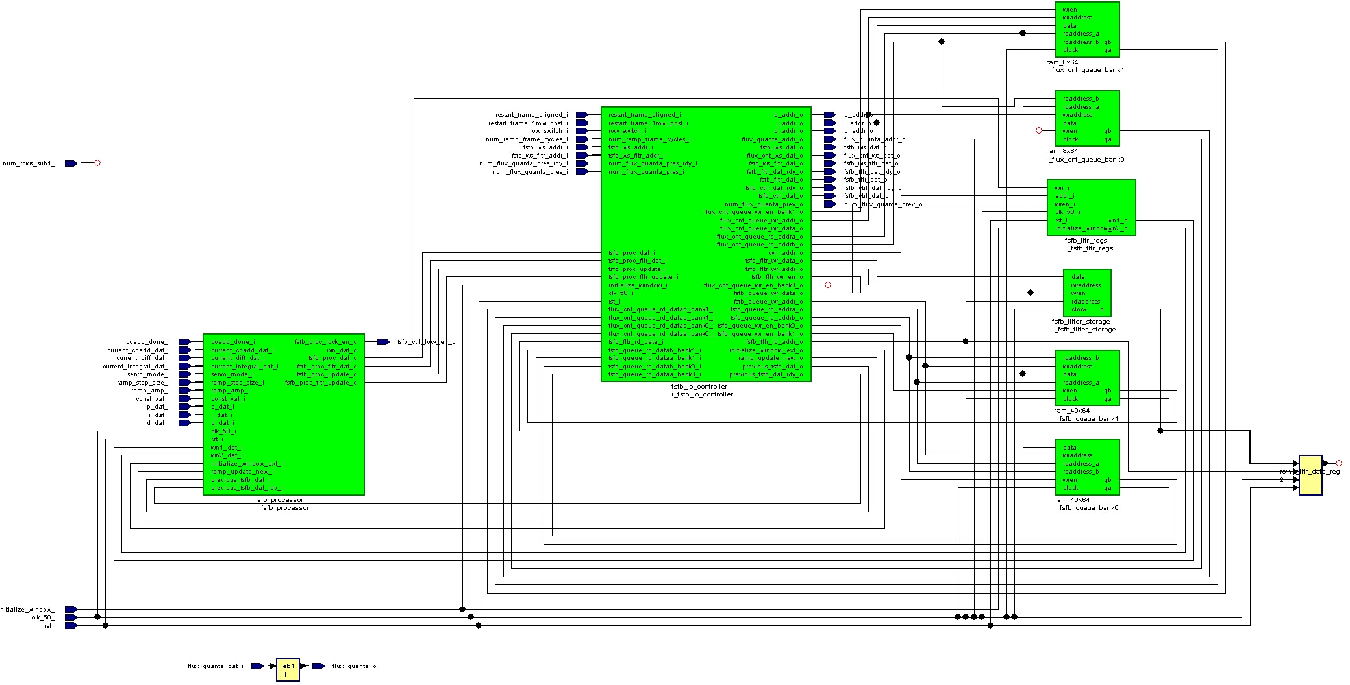
Figure 2: First Stage Feedback Calculator (fsfb_calc)

Block Interfaces

Interface Signal Description
- Interface Signals
Signal | Description | Direction
rst_i | Global block reset | in
clk_50_i | Global clock (50MHz) | in
coadd_done_i | Done signal issued by upstream adc_sample_coadd block to indicate valid coadd data (one clk period pulse) | in
current_coadd_dat_i | Current coadded value (P) | in
current_diff_dat_i | Current difference (D) | in
current_integral_dat_i | Current integral (I) | in
restart_frame_aligned_i | Indicates next clock cycle is the start of frame (one clk period pulse) | in
restart_frame_1row_post_i | Same as restart_frame_aligned_i, except that it is 1 row behind of actual frame start | in
row_switch_i | Row switch signal to indicate next clock cycle is the beginning of new row (one clk period pulse) | in
initialize_window_i | Frame window at which all values read queues equal to fixed preset parameter, FSFB_QUEUE_INIT_VAL, set to 0 | in
num_rows_sub1_i | Number of rows per frame subtract 1 (not used) | in
servo_mode_i | Servo mode selection | in
ramp_step_size_i | Ramp step increment/decrement size | in
ramp_amp_i | Ramp peak amplitude | in
const_val_i | First stage feedback constant value | in
num_ramp_frame_cycles_i | Number of frame cycle ramp result remained level | in
p_addr_o | P coefficient queue address | out
p_dat_i | P coefficient queue data | in
i_addr_o | I coefficient queue address | out
i_dat_i | I coefficient queue data | in
d_addr_o | D coefficient queue address | out
d_dat_i | D coefficient queue data | in
flux_quanta_addr_o | flux quanta queue address | out
flux_quanta_dat_i | flux quanta queue data | in
fsfb_ws_fltr_addr_i | filter-queue read port address for wishbone access | in
fsfb_ws_fltr_dat_o | filter-queue read data address for wishbone access | out
fsfb_ws_addr_i | First stage feedback queue read-port address for wishbone access (previous frame) | in
fsfb_ws_dat_o | First stage feedback queue read-port data for wishbone access (previous frame) | out
flux_cnt_ws_dat_o | wishbone access to read flux count data  (Note that fsfb_ws_addr_i is used as address for reading flux_cnt, because the only data mode that captures flux_cnt is the one that reads 8bit flux count + 24bit fsfb data) | out
fsfb_fltr_dat_rdy_o | First stage feedback queue filter data ready (current frame) | out
fsfb_fltr_dat_o | First stage feedback queue filter data (current frame) | out
fsfb_ctrl_dat_rdy_o | First stage feedback queue control data ready (previous frame) | out
fsfb_ctrl_dat_o | First stage feedback queue control data (previous frame) | out
fsfb_ctrl_lock_en_o | First stage feedback queue control lock data mode enable | out
num_flux_quanta_pres_rdy_i | flux quanta present count ready | in
num_flux_quanta_pres_i | flux quanta present count ready | in
num_flux_quanta_prev_o | flux quanta previous count | out
flux_quanta_o | flux quanta value (formerly know as Z coefficient) | out

Interface Protocol and Timing

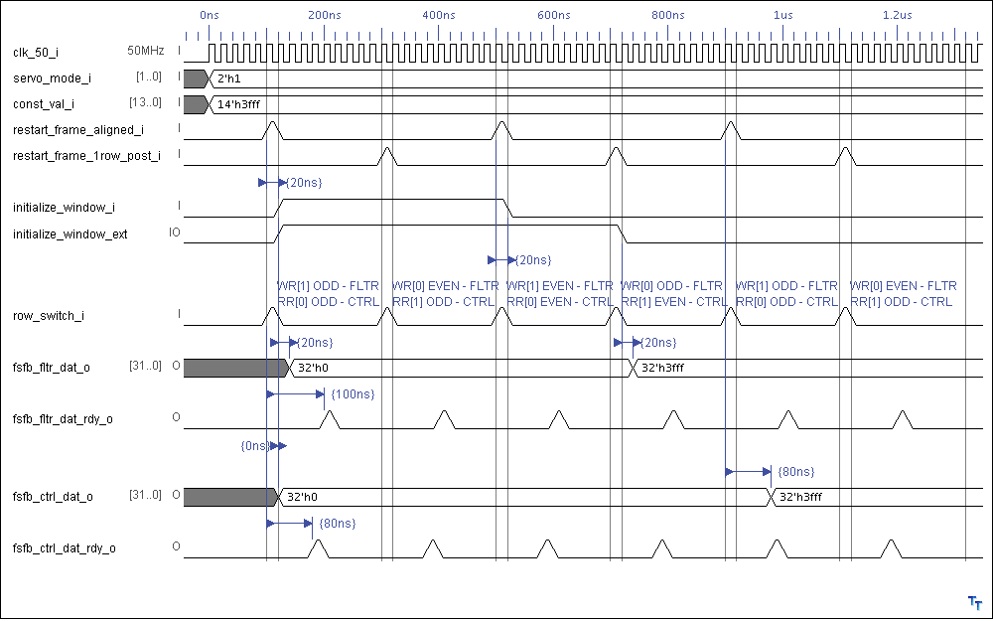
Constant Mode Timing
Figure 3: Interface Timing Diagram 1 (Constant Servo Mode)

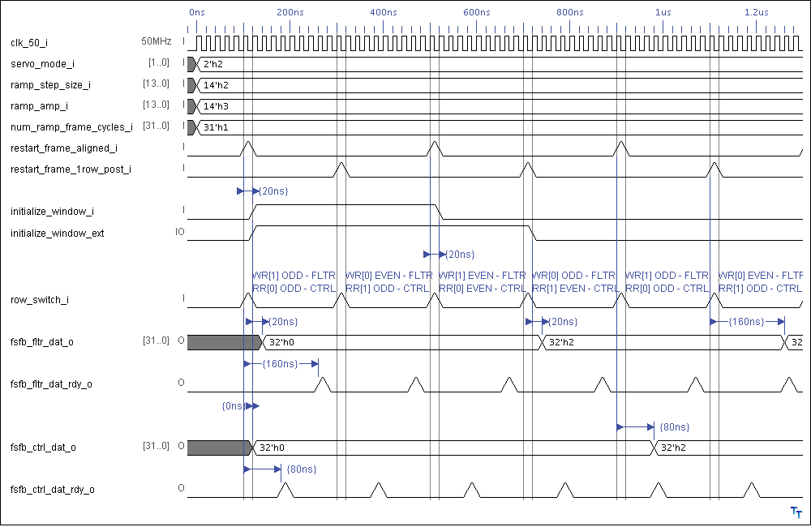
Ramp Mode Timing
Figure 4: Interface Timing Diagram 2-1 (Ramp Servo Mode)
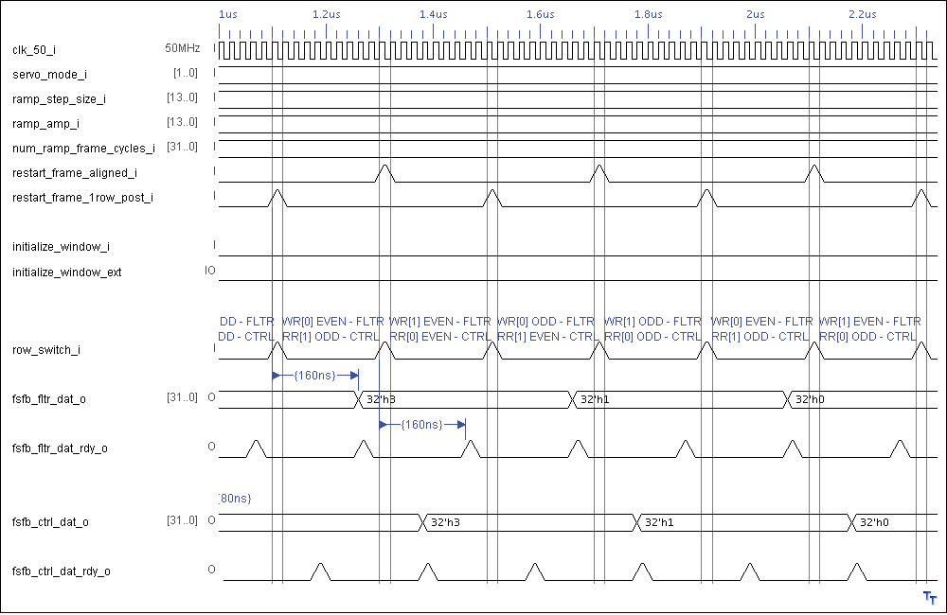
Figure 5: Interface Timing Diagram 2-2 (Ramp Servo Mode)

Lock Mode Timing

Row40 of Frame N of
Sequence X
Row0 of Frame 1
of sequence Y
Clk_50_i
restart_frame_aligned_i
Row1 of Frame 1
of sequence Y
row_switch_i
coadd_done_i
40
p/i/d_addr_o
p/i/d_dat_i
116
fsfb_proc_dat_o
fsfb_fltr_dat_o
fsfb_ctrl_dat_rdy_o

Figure 6: Interface Timing Diagram 3 (Lock Servo Mode)

High-Level Description
The first stage feedback calculator is architected based on its sub-block functionality. It consists of two main sub-blocks and 6 RAM storage blocks; the first stage feedback input/output controller (fsfb_io_controller), processor (fsfb_processor) and the RAM blocks are:
- fsfb_queue_bank0 and fsfb_queue_bank1
- flux_cnt_queue_bank0 and flux_cnt_queue_bank1
- fsfb_fltr_storage
- fsfb_fltr_regs

RAM Storage Blocks

First Stage Feedback Queue (fsfb_queue) Bank 0 (Even) and 1 (Odd)
The first stage feedback queues (fsfb_queue) store the calculated results from the first stage feedback processor (fsfb_processor), so that they can be later read by the wishbone slave frame data (wbs_frame_data) or transferred to the downstream first stage feedback correction (fsfb_corr) block. Two queues (identified as odd and even banks) are required, with one storing the previous-frame data and the other storing the current-frame data. It is important to realize that the wbs_frame_data and fsfb_corr are always accessing the previous frame data, and not the current one. Therefore, when a wishbone read request comes in, the previous frame data is read back right away and the read process is not aligned with the frame boundaries. The first stage feedback input/output controller (fsfb_io_controller) block directs all inputs and outputs to/from the queues.
The first stage feedback queue is created from Altera 3-port RAM Megafunction (shown in Figure 8), with write port dedicated to internal system write (calculation results), one read port dedicated to internal system read (by fsfb_corr), and the other read port dedicated to wishbone read accesses. Note that what Altera calls 3-port is basically a dual-port RAM as commonly referred to in industry.
The RAM block is 64 x 40bit which translates to 6bit address line. The current MCE is configured to use 41 elements, but the RAM block supports extension to 64 elements. Figure 7 provides the bit definition of the 40-bit queue data word. As shown, bit 39 stores the next ramp operation (add = '0', sub = '1') and bits 38 down to 0 store the result. Therefore bit 39 should be ignored in all modes except ramp.

Servo Mode | Bit 39 | Bit 38: 0
01 - Constant | X – don’t care (ignored) | Constant result
10 - Ramp | 0 – add, 1 - subtract | Ramp result
11 - Lock | X – don’t care (ignored) | Lock result
Figure 7: First Stage Feedback Queue Data Word

qa

qb

data

wren
rdaddress_a

wraddress

rdaddress_b

FSFB
QUEUE

64 x 40b

wishbone
(wbs_frame_data)
system
(fsfb_io_controller)
calculating DAC value
(fsfb_corr)
wishbone
(wbs_frame_data)

Figure 8: First Stage Feedback Queue

Flux Count Queue – Bank 0 and Bank 1
These two RAM blocks, 64 x 8b each, are very similar to the fsfb queue RAM blocks. Flux count values are only read in one of the data modes that reads 8b flux count values combined with partial (24b) fsfb data.

First Stage Feedback Filter Queue
This 64 x 32b RAM block stores the filtered output calculation results. The width of this queue is the same as the wishbone data. It is important to note that the filter results are not double buffered, since delay is acceptable in reading filter results. When a wishbone read request comes in, the read starts at the beginning of the next frame, in order to be aligned with the frame boundaries.
qa

data

wren
rdaddress_a

wraddress

Filter
QUEUE

64 x 32b

wishbone
(wbs_frame_data)
wishbone
(wbs_frame_data)

Figure 9: First Stage Feedback Filter Queue

First-Stage Feedback Filter Registers
The fsfb_filter_regs block instantiates 2 RAM blocks to store the previous 2 samples of wn, where wn is the interim filter calculation results. For details of the filter calculations, refer to the fsfb_calculations.doc where the implementation of the second-order Butterworth low-pass filter that is implemented.
The calculations are:
w_{temp} = b₁* w_{n-1} + b₂* w_{n-2}
w_{n} = x_{n} – w_{temp}/2^{m}
y_{n} = w_{n} + 2 * w_{n-1} + w_{n-2}

where x is the input to the filter and y is the output of the filter, b1 and b2 are the filter coefficients, m is the number of bits for the filter coefficients.
Note that the filter is reset through initialize_window_i signal. Each RAM block has 64 words and the word length is determined in the pack file by FLTR_DLY_WIDTH.

Figure 10: Filter Registers Storage

First Stage Feedback Processor (fsfb_processor)
The first stage feedback processor (fsfb_processor) shown in Figure 11 contains the arithmetic/comparison circuitry that calculates the results of the first stage feedback to be written to the first stage feedback queues (fsfb_queue), along with the arithmetic for a 2-pole Butterworth low-pass filter with a cut-off frequency of 50Hz. It supports three servo processing modes: constant, ramp, and lock corresponding to servo mode selection = "01", "10", and "11". "00" selection is invalid. Under this invalid setting, the update pulse (essentially the queue write enable) would not be generated, and hence there would be no update whatsoever. In addition, only the selected result will be output from this block. In other words, there is only a single output to be used by another block and it is the result for the selected servo mode. Meanwhile, when operated in the ramp mode, the new ramp value from the processor block is only written to the queue when the "ramp update new" input from fsfb_io_controller is active.
In all three modes of operation, the timing relationships for the downstream fsfb_ctrl_dat_o and its rdy_o pulse are identical. In other words, the data result for the downstream first stage feedback correction (fsfb_corr) block is always ready 4 system clock cycles (80 ns) after the rising edge of the row_switch. For the first stage feedback filter (fsfb_fltr) block, however, the data result ready timing varies from one mode to another. It depends directly on the number of system clock cycles required for processing data in each mode.
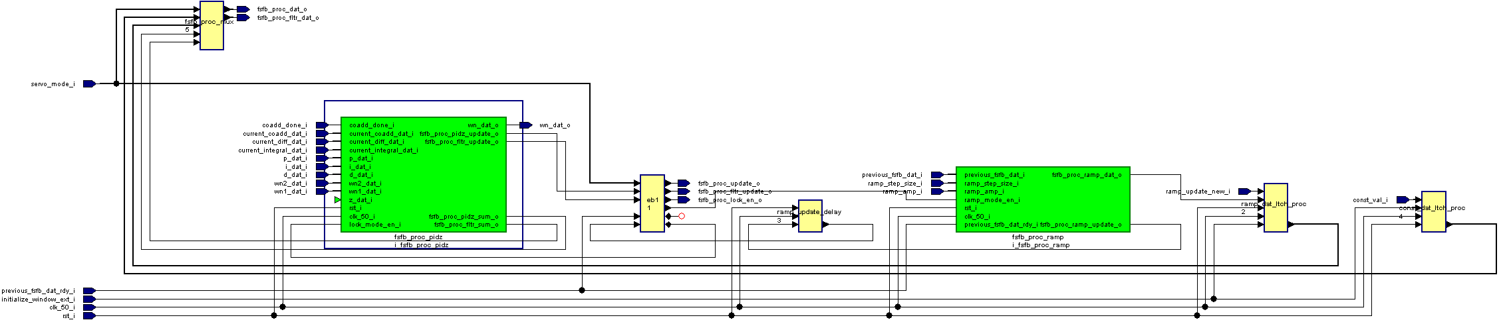

Figure 11: First Stage Feedback Processor

Constant Mode
Constant mode is handled directly by the top-level fsfb_processor block. The constant and servo mode selection values are made available by the wishbone slave feedback data block. These values should be stable before the frame timing block outputs the "initialize window" pulse. The constant value is provided to the downstream first stage feedback filter (fsfb_fltr) and control (fsfb_ctrl) blocks in the second and third frame time window respectively. Figure 3 shows the timing diagram for this mode.

Ramp Mode (fsfb_proc_ramp)
The ramp processor (fsfb_proc_ramp) block shown in Figure 12 handles the ramp mode processing. The ramp step size, amplitude, and servo mode selection are made available by the wishbone slave feedback data block. The values should be stable before the "initialize window" pulse is output by the frame timing block. The generated ramp output always initializes at zero level and gradually increases in step size increments until reaching the maximum level set by the ramp amplitude input. Once it reaches the maximum amplitude, the output ramp is then decremented in the same step size until the zeroed level. The pattern will be repeated continuously. The pace of increment/decrement is dictated by the "ramp_update_new" input derived from the "num_ramp_frame_cycles" wishbone input.
In summary, the first ramp increment value is present on the datapath to the downstream first stage feedback filter (fsfb_fltr) and control (fsfb_ctrl) blocks in the num_ramp_frame_cycles + 1 and +2 frame time window respectively. Figure 4 and Figure 5 show the timing diagram when the num_ramp_frame_cycles is 1. Note that the instantiated 16-bit adder/subtractor is generated through Altera megafunction. The 16-bit add/sub result is zero-padded to 32 bits. Bit 32 is written with '1' when the next ramp operation is subtraction or '0' when addition. This toggling of next operation bit normally occurs when the maximum or zero is reached after a series of ramp addition or subtraction.
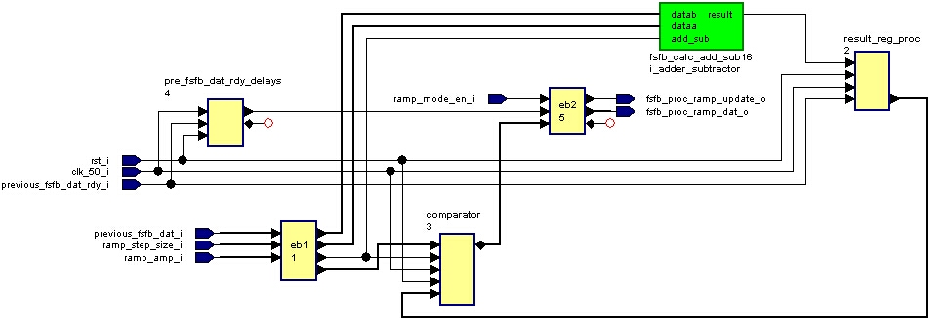
Figure 12: First Stage Feedback Ramp Processor

Lock/PIDZ Mode (fsfb_proc_pidz)
The lock/pidz mode processor (fsfb_proc_pidz) block shown in Figure 13 handles the lock mode calculations which includes PID-loop calculation and low-pass filtering. The results will then be passed to the downstream blocks. Here is a summary of the calculations:
pidz_sum = (P*current_coadd_value) + (I*current integral) + (D*current difference) + Z
fltr_sum (n) = pidz_sum(n) + 2*pidz_sum(n-1) + pidz_sum(n-2) – b1*fltr_sum(n-1) – b2*fltr_sum(n-2)
where n is the sample number.
In order to save the DSP resources, a 32x32b multiplier is shared at different stages of calculation. However, there are separate adders for each addition/subtraction operation. If resource becomes scarce, a shared adder scheme can be adopted. Note that in the current implementation, each of the 8 channels have their dedicated multiplier, therefore, the multiplier in each channel has to be pipelined for different operations. (This was an architectural decision over the model that would have shared one calculation block between all channels and therefore, could afford having dedicated multipliers for each stage of operation.)
A scheduling register, calc_shift_state, is used to schedule the calculations and when to register the results at each stage.
The P, I, D, and Z coefficients are provided by the wb_fb_data (wishbone slave feedback data) block. The filter coefficients are hard-coded in the pack file. There are 41 different sets of coefficient values stored in the pidz_coeff_queue and they should be stable before the frame timing block asserts initialize_window.
The fltr_sum calculations are broken down as follows:
w_{temp} = b₁* w_{n-1} + b₂* w_{n-2} (eq. 1)
w_{n} = pidz_sum_{n} – w_{temp}/2^{m} (eq. 2)
fltr_sum_{n} = w_{n} + 2 * w_{n-1} + w_{n-2} (eq. 3)
To implement the calculation of pidz_sum, one 32-bit multiplier, two 64-bit first-stage adders, and one 65-bit second-stage adder are instantiated. All inputs from the upstream adc_sample_coadd block including current coadd value, integral and difference are valid when the coadd_done pulse is active. After coadd_done is asserted, it takes a total of 5 clock cycles to complete the PID calculation. The multiplier results are valid at the end of the third clock cycle, the first stage adder results (pi_sum and dz_sum) are valid at the fourth and finally the second-stage adder result (pidz_sum) is valid at the fifth clock cycle. This relationship is shown in Figure 6 where the fsfb_proc_pidz_sum_update signal is asserted 5 clock cycles after the incoming coadd_done is asserted.
To implement the fltr_sum calculations, 2 multiply operations have to be performed in eq. 1 above. Note that eq. 2 has to wait for pidz_sum results to be ready, therefore, fltr_sum is only available 8 clock cycles after coadd_done is asserted.
The operations are scheduled as follows:
calc_shift_state (0) P*current_coadd_value = p_product
calc_shift_state (1) I*integral_coadd_value = I_product
calc_shift_state (2) D*difference_coadd_value = D_product
store fltr_tmp = 2 * w_{n-1} + w_{n-2}
calc_shift_state (3) b1*w_{n-1} = b1_product
store pi_sum = p_product + I_product
store dz_sum = d_product + z
calc_shift_state (4) b2*w_{n-2} = b2_product
store pidz_sum = pi_sum + dz_sum
calc_shift_state (5) assert proc_pidz_update
store wtemp = b1_product + b2_product
calc_shift_state (6) store wn = pidz_sum – wtemp/2^{m}
calc_shift_state (7) store fltr_sum = w_{n} + fltr_tmp
calc_shift_state (8) assert proc_fltr_update
It should be noted that although the resultant PIDZ sum is 66-bit wide, the signed result that can be stored is only 40-bit. Because of this, only bits 38 down to 0 represent the magnitude and bit 39 is reserved for sign. This is strictly a limitation of the implemented width size of the first stage feedback queue.
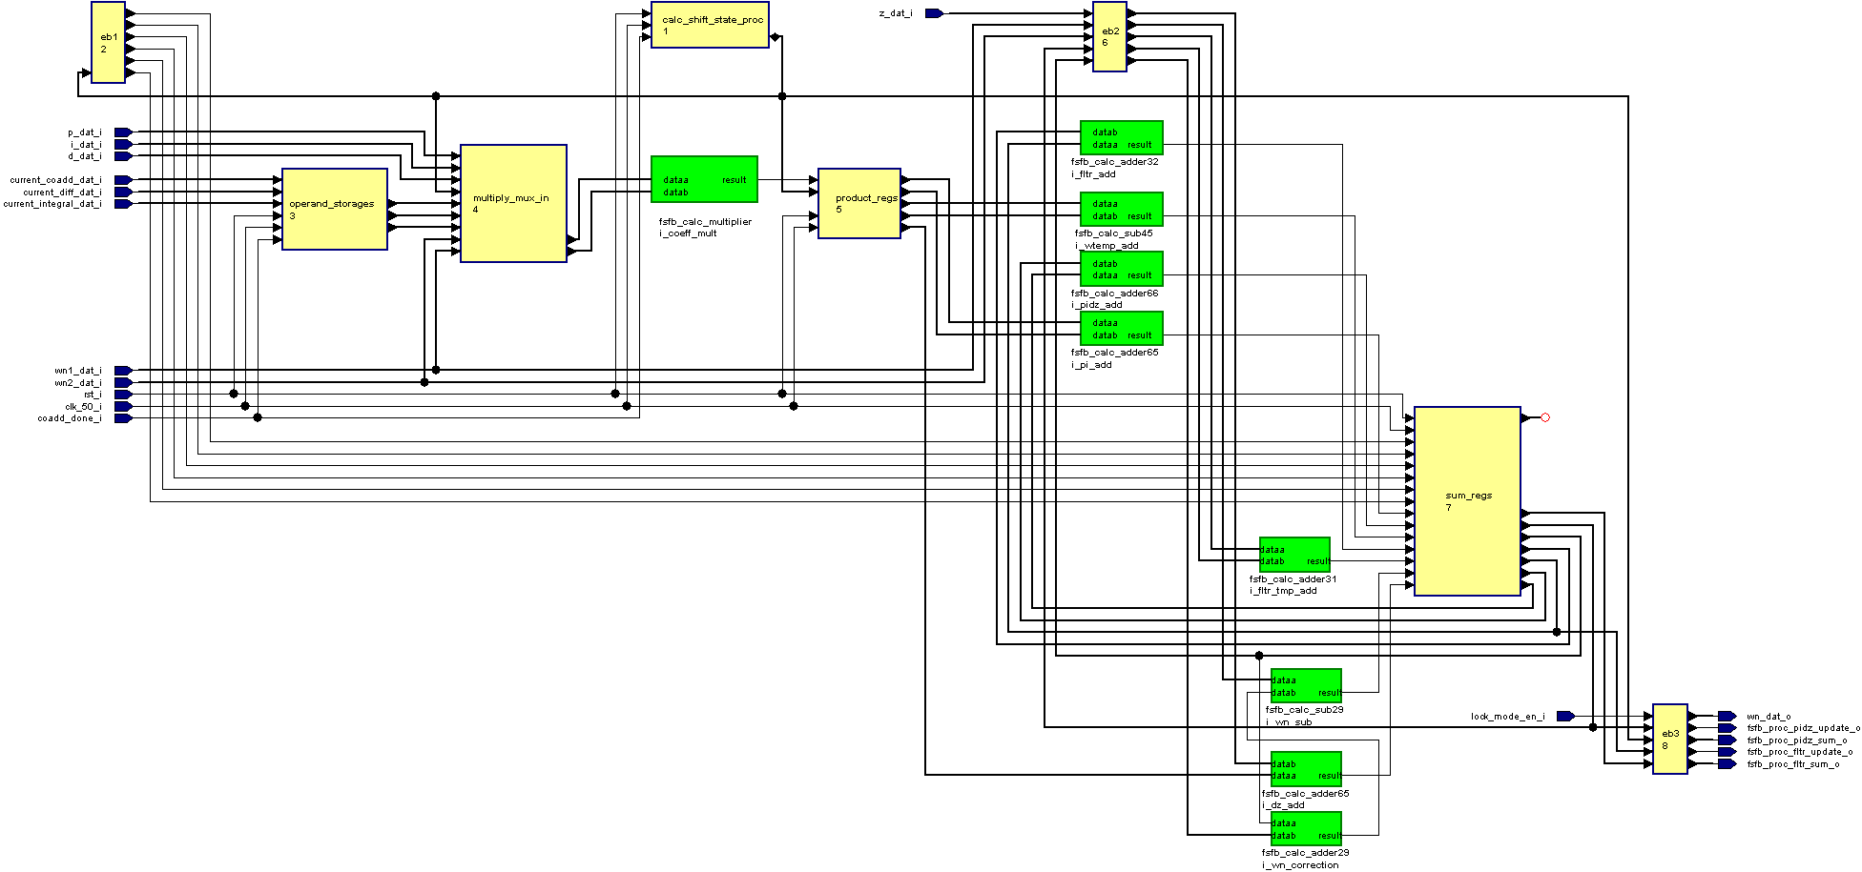
Figure 13: First Stage Feedback Lock/PIDZ Processor

First Stage Feedback Input/Output Controller (fsfb_io_controller)
The first stage feedback input/output controller (fsfb_io_controller) block shown in Figure 14 maintains control over all the input/output traffic to/from the first stage feedback queues. Using signals like "row switch, restart frame aligned and restart frame 1row post" generated by the frame timing block, the controller block ensures the queue read/write address inputs and even/odd bank switching are updated correctly at the right times. By doing this, correct frame data results would then be read/written from/to the queues.
Three different kinds of operation are performed on the queues. They are 1) wishbone read, 2) system read, and 3) system write. The word "system" always refers to the fsfb_calc block.

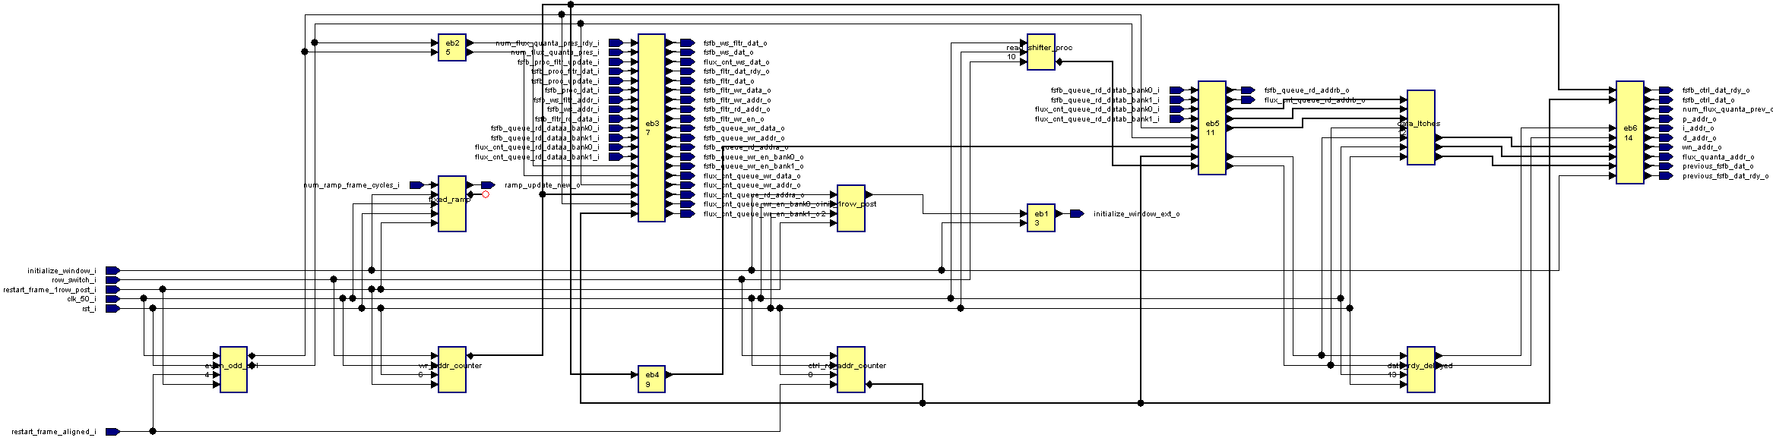
Figure 14: First Stage Feedback Input/Output Controller
As mentioned in the FSFB_QUEUE section, a separate read port is allocated for the wishbone slave. Ideally, the wishbone slave can request for unfiltered data at anytime. However, to get a complete frame worth of data, the wishbone slave must not perform any read close to the boundary between row 0 and 1 of each frame time. The data read is selected from either bank 0 or 1, dependent on the bank selection control.
For every row switch, the fsfb_io_controller block will perform two sequential reads and the reads are performed regardless of the selected servo mode. From the first read, the first stage feedback queue result data is obtained for the downstream first stage feedback control block. This row result has already been calculated in the previous frame time. From the second read, the first stage feedback queue result data in the previous frame time is fetched to update the current ramp value for use in the next frame time. Similar to the wishbone slave, a separate read port is allocated for the system so that no arbitration is required between them.
The well-defined sequence of read operations described above leads to the shift-register based state machine of the controller.
Shift Cycle 0: Write fsfb_ctrl address to RAM read address inputs
Shift Cycle 1: Internal RAM processing; Write system address to RAM read address inputs
Shift Cycle 2: RAM data is valid for fsfb_ctrl
Shift Cycle 3: RAM data is valid for system
Note that each READ from RAM takes 3 cycles to complete.

The system write operation is also straightforward. The write data and write enable are always sourced from the fsfb_processor block outputs. The fsfb_io_controller only updates the write address and demultiplexes the write enable to the right bank. It is important to realize that the two-bank queue structure details are not visible to any block except the fsfb_io_controller.

Files of the Block

Source Code

Fsfb_calc.vhd
This is the top-level component for the first stage feedback calculator.

Fsfb_processor.vhd
This is the top-level component for the first stage feedback processor and is part of fsfb_calc.

Fsfb_proc_ramp.vhd
This is the top-level component for the first stage feedback ramp processor and is part of fsfb_processor.

Fsfb_calc_add_sub16.vhd
This is the top-level component for the 16-bit adder/subtractor and is part of fsfb_proc_ramp.

Fsfb_proc_pidz.vhd
This is the top-level component for the first stage feedback lock/pidz processor and is part of fsfb_processor.

Fsfb_calc_adder65.vhd
This is the top-level component for the 65-bit adder and is part of fsfb_proc_pidz.

Fsfb_calc_adder66.vhd
This is the top-level component for the 66-bit adder and is part of fsfb_proc_pidz.

Fsfb_calc_multiplier.vhd
This is the top-level component for the 32-bit multiplier and is part of fsfb_proc_pidz.

Fsfb_calc_sub45.vhd
This is the top-level component for the 45-bit adder to calculate wtemp and is part of fsfb_proc_pidz.

Fsfb_calc_adder29.vhd
This is the top-level component for the 29-bit adder and is part of fsfb_proc_pidz.

Fsfb_calc_adder31.vhd
This is the top-level component for the 31-bit adder to calculate fltr_tmp and is part of fsfb_proc_pidz.

Fsfb_calc_adder32.vhd
This is the top-level component for the 32-bit adder to calculate fltr_sum and is part of fsfb_proc_pidz.

Fsfb_io_controller.vhd
This is the top-level component for the first stage feedback input-output controller and is part of fsfb_calc.

Fsfb_queue.vhd
This is the top-level component for the first stage feedback queue and is part of fsfb_calc.

fsfb_filter_storage
This is the top-level RAM component for storing filter results and is instantiated in fsfb_calc.

fsfb_fltr_regs
This is the top-level component for storing filter intermediate results and is instantiated in fsfb_calc.

flux_cnt_queue.vhd
This is the top-level RAM component for storing flux count and is instantiated in fsfb_calc.

Header Code

Fsfb_calc_pack.vhd
This is the package file for the first stage feedback calculator. It contains all the constant and component declarations used.

Naming Conventions Used

